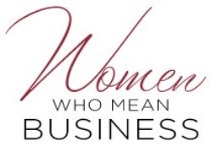
Breakfast
Sponsorships!
December 6, 2017
Oregon Golf Club
8:30-11:00 am

Be a part of our vibrant Women Who Mean business programming by Sponsoring this event. Be visible and relevant to vivacious, driven women in the West Linn community. Limited availability. Sponsorships are available to West Linn Chamber of Commerce members only. Email melinda@westlinnchamber.com to express interest. Requests will be taken on a first come, first served basis.
Diamond Sponsor- One Available for $500
Receives: Complimentary Vendor table
2 Complimentary tickets
Entire back of Program for logo or article about their business
3 minutes to talk at the beginning of programming at the podium
Mention in both newsletters and Facebook

Emerald Sponsor: 4 available for $250/each
Receives: Two Complimentary tickets
Logo on front of program
One minute to introduce yourself and product to the group from your seat
Mention in both newsletters and Facebook

Ruby Sponsor: 10 available for $100/each
Receives: Name listed on the front of the program
Verbal thank you during the presentation
Mention in both newsletters and Facebook

